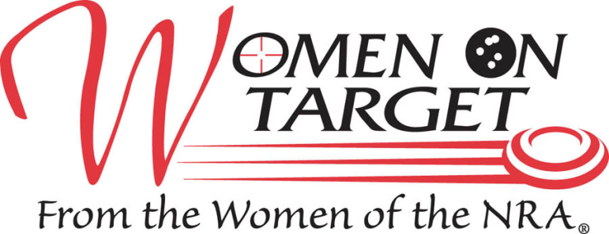

LADIES ONLY
INSTRUCTIONAL SHOOTING CLINIC
16 years or older
Women with little to no shooting experience welcome!
RIFLE * PISTOL * SHOTGUN * ARCHERY
Firearms, Ammunition, Targets, Eye and Ear Protection, Light Breakfast and Lunch are provided

June 10, 2017
8:30 A.M. – 5:00 P.M.

ADVANCE PAYMENT, WAIVERS AND REGISTRATION REQUIRED
$75.00

For more information contact:
Registration forms will be available at Tri-County Sportsmen’s League or online at TCSL.org starting April 1st and
Spaces fill up FAST, so don’t wait!

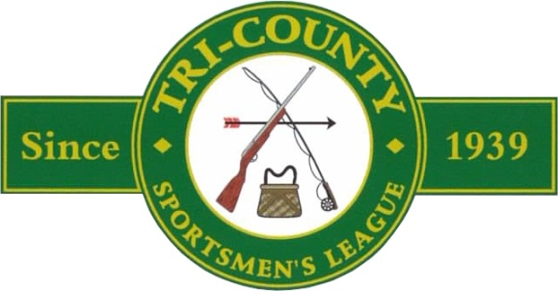

8640 Moon Rd., Saline, MI 48176

