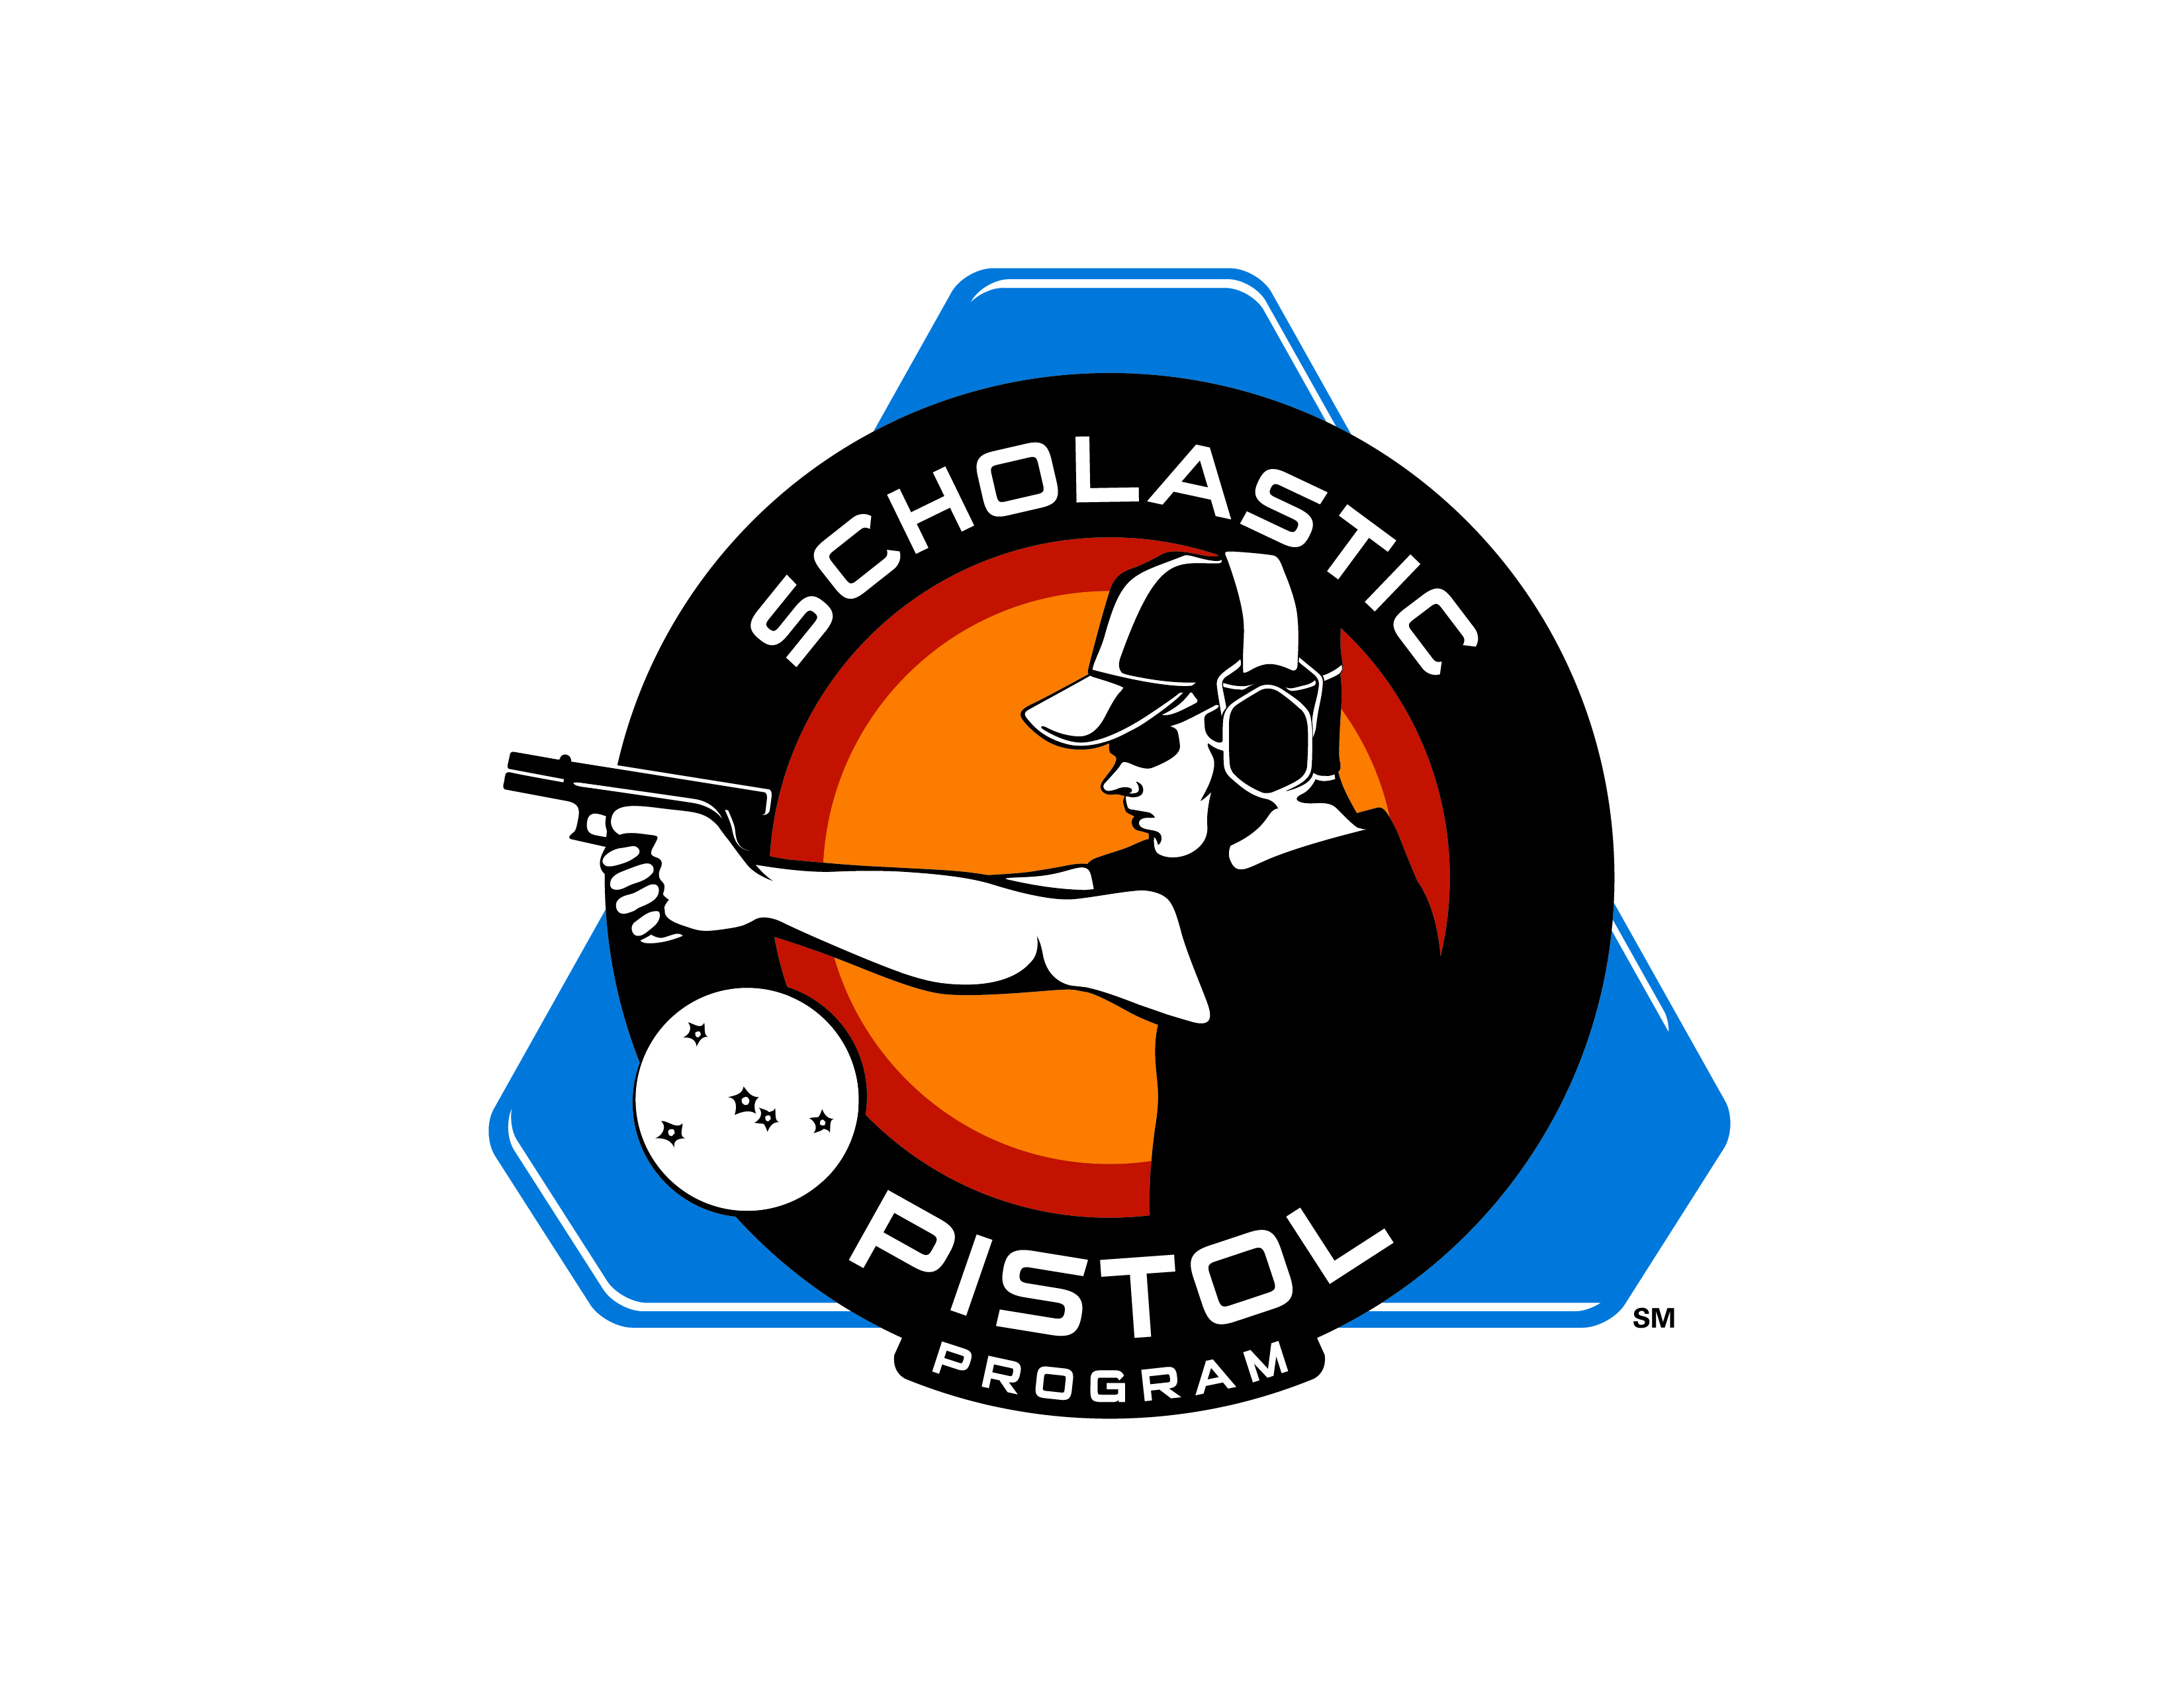

**Material/Equipment to start a Scholastic Pistol Program (SPP) team**

The Scholastic Pistol Program (SPP) is an easy sport to learn and the material list is fairly simple. The following are the basic needs to start a team. Please refer to rule book for a full description of the specific items.

Handgun:

Centerfire: All SPP matches will be shot with any “stock” handgun

Rimfire: ALL SPP rimfire matches will be shot with handguns with iron sights only

Ammunition:

Centerfire: While 9mm Luger (9x19) is the recommended caliber for SPP, .40 S&W, 45ACP or .38 Special may be used

Rimfire: .22 Long Rifle ammunition

Steel Targets

Timer

Ear & Eye Protection

Paint (flat white, red, black)

Measuring Tape

Gun Range with at least one bay at least 25 yards deep

SPP Discount Programs (as of 8-26-13)

Handguns:

GLOCK

Smith & Wesson

Ammunition;

Atlanta Arms & Ammo

Winchester Ammunition

Steel Targets:

Action Targets

GT Targets

Timers:

PACT Timers

Ear Protection:

PRO – EARS

Eye Protection:

Rudy Project

.22 Conversion for GLOCK 17/34:

Tactical Solutions

Cost to Start a Team – Without targets (costs are approximate might not include taxes and shipping)

Centerfire:

Handgun - $400

Timer - $95

Ear & Eye protection – depends on make & model

Rimfire:

Handgun: $300

Timer - $95

Ear & Eye protection - depends on make & model

Targets:

Full set (20 targets): $2,000

8/26/13